1. Create databases with names “empdatabase” and “studentdatabase”.

2. Create a table under empdatabase with name “emp” with columns id, name, dept, sal and experience.

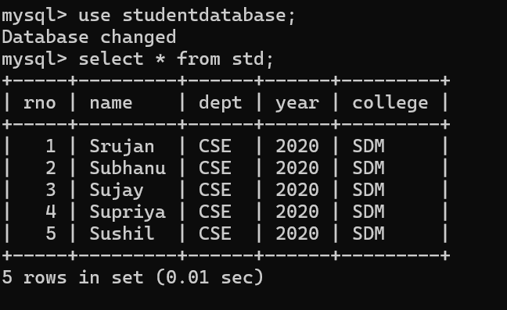3. Insert a minimum of 5 employees&#39; data records into the emp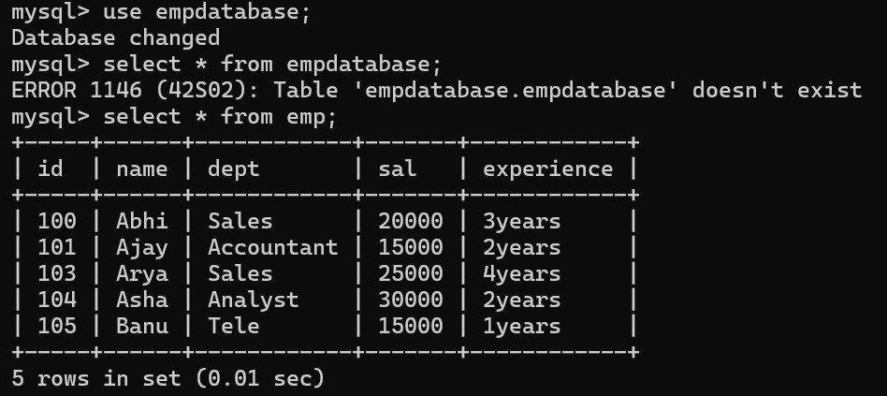 table.

4. Create a table under studentdatabase with name “std” with columns rno, name, dept, year and college.

5. Insert a minimum of 5 students&#39; data records into the std table.